UNIT - V

File System Interface and Operations -Access methods, Directory Structure, Protection, File System Structure, Allocation methods, Free-space Management. Usage of open, create, read, write, close, lseek, stat, ioctl system calls.

5.1.1 File System Interface and Operations
For the majority of users, the file system is the most obvious aspect of any operating system. This provides users the method for storage and access to data as well as programs of the operating system where all the users of the computer system can use it.
The file system consists of 2 distinct parts:
- a collection of files, that store related data, and
- a directory structure, which organizes and provides information about all the files in the system.
And also The file system consists of different file attribute, concepts of file and its storage along with operations on files.
1. File Attributes
2. Fundamental Components of A File
3. File Operations

File Attributes
A file is named, for the ease of its users and is referred by its name. A name is usually a string of characters like filename.cpp, along with an extension which designates the file format. Some systems (like Linux) distinguish between uppercase and lowercase characters in names, whereas other systems don't. When a file is given a name, it becomes independent of the process, the user and also the system which created it. Let's suppose, one user might make the file filename.cpp, and another user might be editing that file by deducing its name. The file's owner may write the file to a compact disk (CD) or send it via an e-mail or copy it across a network, and it could still be called filename.cpp on the destination system.

Fundamental Components of A File
A file's attributes vary from one operating system to another but typically consist of these:
- Name: Name is the symbolic file name and is the only information kept in human readable form.
- Identifier: This unique tag is a number that identifies the file within the file system; it is in non-human-readable form of the file.
- Type: This information is needed for systems which support different types of files or its format.
- Location: This information is a pointer to a device which points to the location of the file on the device where it is stored.
- Size: The current size of the file (which is in bytes, words, etc.) which possibly the maximum allowed size gets included in this attribute.
- Protection: Access-control information establishes who can do the reading, writing, executing, etc.
- Date, Time & user identification: This information might be kept for the creation of the file, its last modification and last used. These data might be useful for in the field of protection, security, and monitoring its usage.

File Operations
A file is an abstract data type. For defining a file properly, we need to consider the operations that can be performed on files. The operating system can provide system calls to create, write, read, reposition, delete, and truncate files. There are six basic file operations within an Operating system. These are:
- Creating a file: There are two steps necessary for creating a file. First, space in the file system must be found for the file. We discuss how to allocate space for the file. Second, an entry for the new file must be made in the directory.
- Writing a file: To write to a file, you make a system call specify about both the name of the file along with the information to be written to the file.
- Reading a file: To read from a file, you use a system call which specifies the name of the file and where within memory the next block of the file should be placed.
- Repositioning inside a file: The directory is then searched for the suitable entry, and the 'current-file-position' pointer is relocating to a given value. Relocating within a file need not require any actual I/O. This file operation is also termed as 'file seek.'
- Deleting a file: For deleting a file, you have to search the directory for the specific file. Deleting that file or directory release all file space so that other files can re-use that space.
- Truncating a file: The user may wish for erasing the contents of a file but keep the attributes same. Rather than deleting the file and then recreate it, this utility allows all attributes to remain unchanged — except the file length — and let the user add or edit the file content.

5.1.2 File-System-Implementation in Operating Ssytems
The file system provides the means for online storage and accessing of file contents, including data and its programs. The file system exists in permanently on secondary storage that is designed for holding a large amount of permanent data.
Mainly concerned with issues related to file storage and accessing them on the most common secondary storage standard, i.e., the disk. It consists of following parts:
1. File-System Structure
2. Basic File System Structure
3. File-System Implementation

File-System Structure
Disks offer the massive amount of secondary storage where a file system can be maintained. They have two characteristics which make them a suitable medium for storing various files -
- A disk can be used to rewrite in place; it is possible to read a chunk from the disk, modify the chunk and write it back there in the same place.
- A disk can access directly any given block of data it contains. Hence, it is easy to access any file either in sequence or at random and switching from one single file to another need only to move the read-write heads and wait for the disk to rotate to that specific location.

Basic File System Structure
The basic file system requires only issuing generic commands for the appropriate device driver mainly for reading and writing physical blocks on the disk. Each physical block can be recognized by its numeric disk address (like this: drive 1, cylinder 62, track 2, sector 14).

File-System Implementation
Numerous on-disk and in-memory configurations and structures are being used for implementing a file system. These structures differ based on the operating system and the file system but applying some general principles. Here they are portrayed below:
- A boot control block usually contains the information required by the system for booting an operating system from that volume. When the disks do not contain any operating system, this block can be treated as empty. This is typically the first chunk of a volume. In UFS, this is termed as the boot block; in NTFS, it is the partition boot sector.
- A volume control block holds volume or the partition details, such as the number of blocks in the partition, size of the blocks or chunks, free-block count along with free-block pointers. In UFS, it is termed as superblock; in NTFS, it is stored in the master file table.
- A directory structure per file system is required for organizing the files. In UFS, it held the file names and associated 'inode' numbers. In NTFS, it gets stored in the master file table.
- The FCB contains many details regarding any file which includes file permissions, ownership; the size of file and location of data blocks. In UFS, it is called the inode. In NTFS, this information gets stored within the master file table that uses a relational database (RDBM) structure, using a row per file.

5.2 Access methods
When a file is used, information is read and accessed into computer memory and there are several ways to access this information of the file. Some systems provide only one access method for files. Other systems, such as those of IBM, support many access methods, and choosing the right one for a particular application is a major design problem.
There are three ways to access a file into a computer system: Sequential-Access, Direct Access, Index sequential Method.
Sequential Access –
It is the simplest access method. Information in the file is processed in order, one record after the other. This mode of access is by far the most common; for example, editor and compiler usually access the file in this fashion
Read and write make up the bulk of the operation on a file. A read operation -read next- read the next position of the file and automatically advance a file pointer, which keeps track I/O location. Similarly, for the writewrite next append to the end of the file and advance to the newly written material.
Key points:
- Data is accessed one record right after another record in an order.
- When we use read command, it move ahead pointer by one
- When we use write command, it will allocate memory and move the pointer to the end of the file
- Such a method is reasonable for tape.

Direct-Access
Another method is direct access method also known as relative access method. A filed-length logical record that allows the program to read and write record rapidly. in no particular order. The direct access is based on the disk model of a file since disk allows random access to any file block. For direct access, the file is viewed as a numbered sequence of block or record. Thus, we may read block 14 then block 59 and then we can write block 17. There is no restriction on the order of reading and writing for a direct access file.

A block number provided by the user to the operating system is normally a relative block number, the first relative block of the file is 0 and then 1 and so on.

Index sequential method
It is the other method of accessing a file which is built on the top of the direct access method. These methods construct an index for the file. The index, like an index in the back of a book, contains the pointer to the various blocks. To find a record in the file, we first search the index and then by the help of pointer we access the file directly.

Key points:
  - It is built on top of Sequential access.
  - It control the pointer by using index.

5.3 Directory Structure
Directory can be defined as the listing of the related files on the disk. The directory may store some or the entire file attributes.
To get the benefit of different file systems on the different operating systems, A hard disk can be divided into the number of partitions of different sizes. The partitions are also called volumes or mini disks.
Each partition must have at least one directory in which, all the files of the partition can be listed. A directory entry is maintained for each file in the directory which stores all the information related to that file.
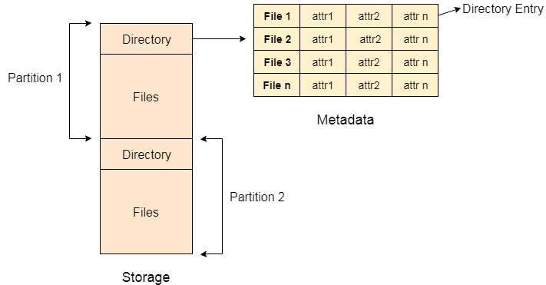

A directory can be viewed as a file which contains the Meta data of the bunch of files. Every Directory supports a number of common operations on the file:
- File Creation
- Search for the file
- File deletion
- Renaming the file
- Traversing Files
- Listing of files

Single Level Directory
The simplest method is to have one big list of all the files on the disk. The entire system will contain only one directory which is supposed to mention all the files present in the file system. The directory contains one entry per each file present on the file system.
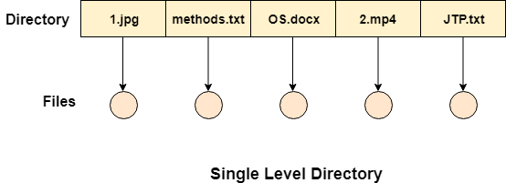
This type of directories can be used for a simple system.

Advantages
- Implementation is very simple.
- If the sizes of the files are very small then the searching becomes faster.
- File creation, searching, deletion is very simple since we have only one directory.

Disadvantages
- We cannot have two files with the same name.
- The directory may be very big therefore searching for a file may take so much time.
- Protection cannot be implemented for multiple users.
- There are no ways to group same kind of files.
- Choosing the unique name for every file is a bit complex and limits the number of files in the system because most of the Operating System limits the number of characters used to construct the file name.

Two Level Directory
In two level directory systems, we can create a separate directory for each user. There is one master directory which contains separate directories dedicated to each user. For each user, there is a different directory present at the second level, containing group of user's file. The system doesn't let a user to enter in the other user's directory without permission.
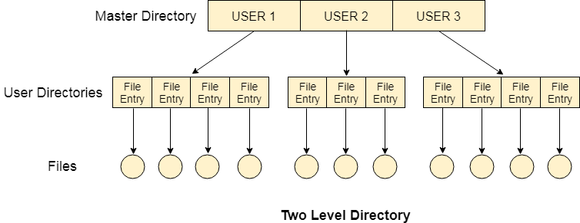

Characteristics of two level directory system
- Each files has a path name as /User-name/directory-name/
- Different users can have the same file name.
- Searching becomes more efficient as only one user's list needs to be traversed.
- The same kind of files cannot be grouped into a single directory for a particular user.
Every Operating System maintains a variable as PWD which contains the present directory name (present user name) so that the searching can be done appropriately.

Tree Structured Directory
In Tree structured directory system, any directory entry can either be a file or sub directory. Tree structured directory system overcomes the drawbacks of two level directory system. The similar kind of files can now be grouped in one directory.
Each user has its own directory and it cannot enter in the other user's directory. However, the user has the permission to read the root's data but he cannot write or modify this. Only administrator of the system has the complete access of root directory.
Searching is more efficient in this directory structure. The concept of current working directory is used. A file can be accessed by two types of path, either relative or absolute.
Absolute path is the path of the file with respect to the root directory of the system while relative path is the path with respect to the current working directory of the system. In tree structured directory systems, the user is given the privilege to create the files as well as directories.
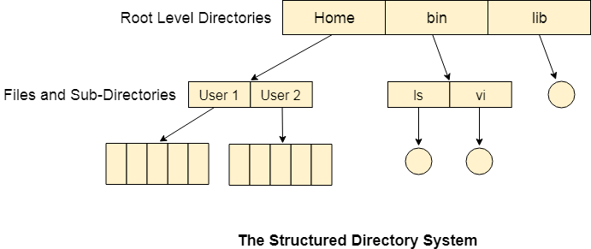

Permissions on the file and directory
A tree structured directory system may consist of various levels therefore there is a set of permissions assigned to each file and directory.
The permissions are R W X which are regarding reading, writing and the execution of the files or directory. The permissions are assigned to three types of users: owner, group and others.
There is a identification bit which differentiate between directory and file. For a directory, it is d and for a file, it is dot (.)
The following snapshot shows the permissions assigned to a file in a Linux based system. Initial bit d represents that it is a directory.

Acyclic-Graph Structured Directories
The tree structured directory system doesn't allow the same file to exist in multiple directories therefore sharing is major concern in tree structured directory system. We can provide sharing by making the directory an acyclic graph. In this system, two or more directory entry can point to the same file or sub directory. That file or sub directory is shared between the two directory entries.
These kinds of directory graphs can be made using links or aliases. We can have multiple paths for a same file. Links can either be symbolic (logical) or hard link (physical).
If a file gets deleted in acyclic graph structured directory system, then
- In the case of soft link, the file just gets deleted and we are left with a dangling pointer.
- In the case of hard link, the actual file will be deleted only if all the references to it gets deleted.
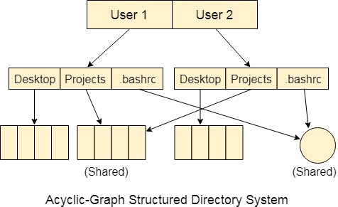

5.4 Protection
Protection refers to a mechanism which controls the access of programs, processes, or users to the resources defined by a computer system. We can take protection as a helper to multi programming operating system, so that many users might safely share a common logical name space such as directory or files.

Need of Protection:
- To prevent the access of unauthorized users and
- To ensure that each active programs or processes in the system uses resources only as the stated policy,
- To improve reliability by detecting latent errors.

Role of Protection:
The role of protection is to provide a mechanism that implement policies which defines the uses of resources in the computer system.Some policies are defined at the time of design of the system, some are designed by management of the system and some are defined by the users of the system to protect their own files and programs.

Every application has different policies for use of the resources and they may change over time so protection of the system is not only concern of the designer of the operating system. Application programmer should also design the protection mechanism to protect their system against misuse.
Policy is different from mechanism. Mechanisms determine how something will be done and policies determine what will be done.Policies are changed over time and place to place. Separation of mechanism and policy is important for the flexibility of the system.

5.5 File System Structure
File System provide efficient access to the disk by allowing data to be stored, located and retrieved in a convenient way. A file System must be able to store the file, locate the file and retrieve the file.
Most of the Operating Systems use layering approach for every task including file systems. Every layer of the file system is responsible for some activities.
The image shown below, elaborates how the file system is divided in different layers, and also the functionality of each layer.
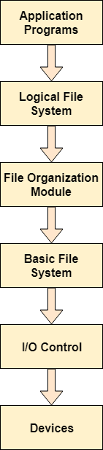

- When an application program asks for a file, the first request is directed to the logical file system. The logical file system contains the Meta data of the file and directory structure. If the application program doesn't have the required permissions of the file then this layer will throw an error. Logical file systems also verify the path to the file.
- Generally, files are divided into various logical blocks. Files are to be stored in the hard disk and to be retrieved from the hard disk. Hard disk is divided into various tracks and sectors. Therefore, in order to store and retrieve the files, the logical blocks need to be mapped to physical blocks. This mapping is done by File organization module. It is also responsible for free space management.
- Once File organization module decided which physical block the application program needs, it passes this information to basic file system. The basic file system is responsible for issuing the commands to I/O control in order to fetch those blocks.
- I/O controls contain the codes by using which it can access hard disk. These codes are known as device drivers. I/O controls are also responsible for handling interrupts.
5.6 Allocation methods
The allocation methods define how the files are stored in the disk blocks. There are three main disk space or file allocation methods.
- Contiguous Allocation
- Linked Allocation
- Indexed Allocation

The main idea behind these methods is to provide:
- Efficient disk space utilization.
- Fast access to the file blocks.

All the three methods have their own advantages and disadvantages as discussed below:

1. Contiguous Allocation

In this scheme, each file occupies a contiguous set of blocks on the disk. For example, if a file requires n blocks and is given a block b as the starting location, then the blocks assigned to the file will be: b, b+1, b+2,……b+n-1. This means that given the starting block address and the length of the file (in terms of blocks required), we can determine the blocks occupied by the file.
The directory entry for a file with contiguous allocation contains

- Address of starting block
- Length of the allocated portion.

The file ‘mail’ in the following figure starts from the block 19 with length = 6 blocks. Therefore, it occupies 19, 20, 21, 22, 23, 24 blocks.
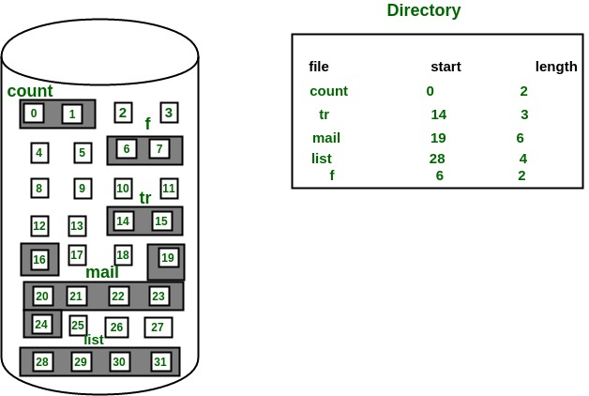

Advantages:

- Both the Sequential and Direct Accesses are supported by this. For direct access, the address of the kth block of the file which starts at block b can easily be obtained as (b+k).
- This is extremely fast since the number of seeks are minimal because of contiguous allocation of file blocks.

Disadvantages:
- This method suffers from both internal and external fragmentation. This makes it inefficient in terms of memory utilization.
- Increasing file size is difficult because it depends on the availability of contiguous memory at a particular instance.

2. Linked List Allocation
In this scheme, each file is a linked list of disk blocks which need not be contiguous. The disk blocks can be scattered anywhere on the disk.
The directory entry contains a pointer to the starting and the ending file block. Each block contains a pointer to the next block occupied by the file.
The file ‘jeep’ in following image shows how the blocks are randomly distributed. The last block (25) contains -1 indicating a null pointer and does not point to any other block.
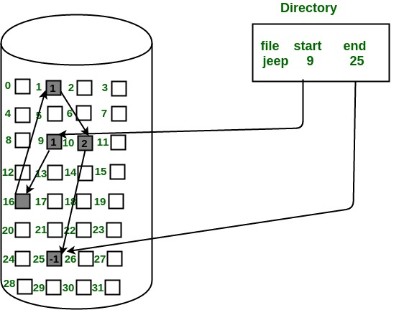

Advantages:
- This is very flexible in terms of file size. File size can be increased easily since the system does not have to look for a contiguous chunk of memory.
- This method does not suffer from external fragmentation. This makes it relatively better in terms of memory utilization.

Disadvantages:
- Because the file blocks are distributed randomly on the disk, a large number of seeks are needed to access every block individually. This makes linked allocation slower.
- It does not support random or direct access. We can not directly access the blocks of a file. A block k of a file can be accessed by traversing k blocks sequentially (sequential access ) from the starting block of the file via block pointers.
- Pointers required in the linked allocation incur some extra overhead.

3. Indexed Allocation
In this scheme, a special block known as the Index block contains the pointers to all the blocks occupied by a file. Each file has its own index block. The ith entry in the index block contains the disk address of the ith file block. The directory entry contains the address of the index block as shown in the image:
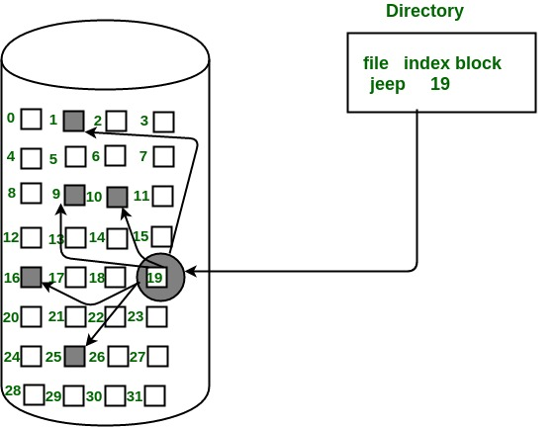
Advantages:
- This supports direct access to the blocks occupied by the file and therefore provides fast access to the file blocks.
- It overcomes the problem of external fragmentation.

Disadvantages:
- The pointer overhead for indexed allocation is greater than linked allocation.
- For very small files, say files that expand only 2-3 blocks, the indexed allocation would keep one entire block (index block) for the pointers which is inefficient in terms of memory utilization. However, in linked allocation we lose the space of only 1 pointer per block.

For files that are very large, single index block may not be able to hold all the pointers.
Following mechanisms can be used to resolve this:
- Linked scheme: This scheme links two or more index blocks together for holding the pointers. Every index block would then contain a pointer or the address to the next index block.
- Multilevel index: In this policy, a first level index block is used to point to the second level index blocks which inturn points to the disk blocks occupied by the file. This can be extended to 3 or more levels depending on the maximum file size.
- Combined Scheme: In this scheme, a special block called the Inode (information Node) contains all the information about the file such as the name, size, authority, etc and the remaining space of Inode is used to store the Disk Block addresses which contain the actual file as shown in the image below. The first few of these pointers in Inode point to the direct blocks i.e the pointers contain the addresses of the disk blocks that contain data of the file. The next few pointers point to indirect blocks. Indirect blocks may be single indirect, double indirect or triple indirect. Single Indirect block is the disk block that does not contain the file data but the disk address of the blocks that contain the file data. Similarly, double indirect blocks do not contain the file data but the disk address of the blocks that contain the address of the blocks containing the file data.
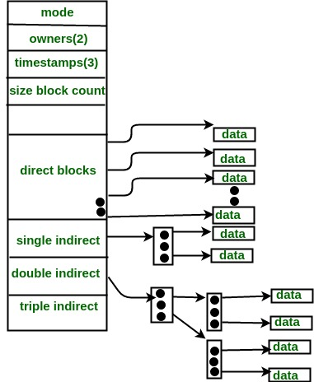

5.7 Free-space Management
The system maintains a free space list which keeps track of the disk blocks that are not allocated to some file or directory. The free space list can be implemented mainly as:
- Bitmap or Bit vector : A Bitmap or Bit Vector is series or collection of bits where each bit corresponds to a disk block. The bit can take two values: 0 and 1: 0 indicates that the block is allocated and 1 indicates a free block.
The given instance of disk blocks on the disk in Figure 1 (where green blocks are allocated) can be represented by a bitmap of 16 bits as: 0000111000000110.
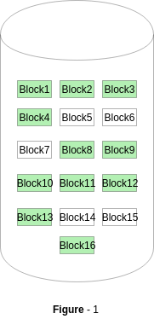
Advantages –
  - Simple to understand.
  - Finding the first free block is efficient. It requires scanning the words (a group of 8 bits) in a bitmap for a non-zero word. (A 0-valued word has all bits 0). The first free block is then found by scanning for the first 1 bit in the non-zero word.

The block number can be calculated as:
(number of bits per word) *(number of 0-values words) + offset of bit first bit 1 in the non-zero word .
For the Figure-1, we scan the bitmap sequentially for the first non-zero word.
The first group of 8 bits (00001110) constitute a non-zero word since all bits are not 0. After the non-0 word is found, we look for the first 1 bit. This is the 5th bit of the non-zero word. So, offset = 5.
Therefore, the first free block number = 8*0+5 = 5.

Linked-List
In this approach, the free disk blocks are linked together i.e. a free block contains a pointer to the next free block. The block number of the very first disk block is stored at a separate location on disk and is also cached in memory.
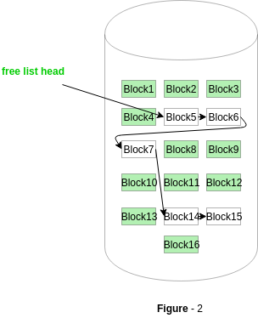
In Figure-2, the free space list head points to Block 5 which points to Block 6, the next free block and so on. The last free block would contain a null pointer indicating the end of free list.
A drawback of this method is the I/O required for free space list traversal.

Grouping
This approach stores the address of the free blocks in the first free block. The first free block stores the address of some, say n free blocks. Out of these n blocks, the first n-1 blocks are actually free and the last block contains the address of next free n blocks.
An advantage of this approach is that the addresses of a group of free disk blocks can be found easily.

Counting
This approach stores the address of the first free disk block and a number n of free contiguous disk blocks that follow the first block.
Every entry in the list would contain:

  - Address of first free disk block
  - A number n

For example, in Figure-1, the first entry of the free space list would be: ([Address of Block 5], 2), because 2 contiguous free blocks follow block 5

5.8 System calls of create, read, write, open ,close, lseek, stat, ioctl
File descriptor : File descriptor is integer that uniquely identifies an open file of the process.
File Descriptor table: File descriptor table is the collection of integer array indices that are file descriptors in which elements are pointers to file table entries. One unique file descriptors table is provided in operating system for each process.

File Table Entry: File table entries is a structure In-memory surrogate for an open file, which is created when process request to opens file and these entries maintains file position.

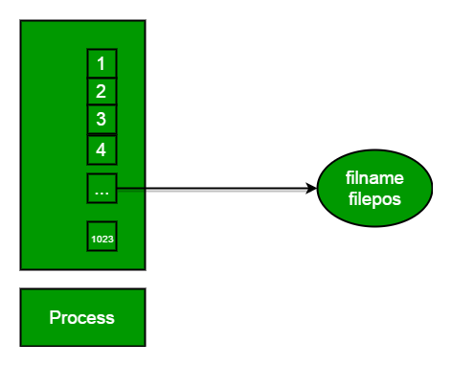

Standard File Descriptors: When any process starts, then that process file descriptors table’s fd(file descriptor) 0, 1, 2 open automatically, (By default) each of these 3 fd references file table entry for a file named /dev/tty.
/dev/tty: In-memory surrogate for the terminal
Terminal: Combination keyboard/video screen

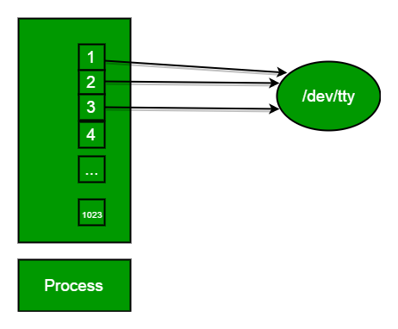
Read from stdin => read from fd 0 : Whenever we write any character from keyboard, it read from stdin through fd 0 and save to file named /dev/tty.
Write to stdout => write to fd 1 : Whenever we see any output to the video screen, it’s from the file named /dev/tty and written to stdout in screen through fd 1.
Write to stderr => write to fd 2 : We see any error to the video screen, it is also from that file write to stderr in screen through fd 2.

Basically there are total 5 types of I/O system calls:

1. Create: Used to Create a new empty file.
Syntax in C language:
int creat(char *filename, mode_t mode)

Parameter :
- filename : name of the file which you want to create
- mode : indicates permissions of new file.

Returns :
- return first unused file descriptor (generally 3 when first creat use in process beacuse 0, 1, 2 fd are reserved)
- return -1 when error

How it work in OS
- Create new empty file on disk
- Create file table entry
- Set first unused file descriptor to point to file table entry
- Return file descriptor used, -1 upon failure

Ex:
// C program to illustrate
// open system call
#include<stdio.h>
#include<fcntl.h>
#include<errno.h>
extern int errno;
int main()
{
// if file does not have in directory
// then file foo.txt is created.
int fd = open("foo.txt", O_RDONLY | O_CREAT);

printf("fd = %d/n", fd);

if (fd ==-1)
{
// print which type of error have in a code
printf("Error Number % d\n", errno);

// print program detail "Success or failure"
perror("Program");
}
return 0;
}

2. Open: Used to Open the file for reading, writing or both.

Syntax in C language
#include<sys/types.h>
#includ<sys/stat.h>
#include <fcntl.h>
int open (const char* Path, int flags [, int mode ]);

Parameters

Path : path to file which you want to use
  - use absolute path begin with “/”, when you are not work in same directory of file.
  - Use relative path which is only file name with extension, when you are work in same directory of file.

flags : How you like to use
  - O_RDONLY: read only, O_WRONLY: write only, O_RDWR: read and write, O_CREAT: create file if it doesn’t exist, O_EXCL: prevent creation if it already exists

How it works in OS
- Find existing file on disk
- Create file table entry
- Set first unused file descriptor to point to file table entry
- Return file descriptor used, -1 upon failure
Ex:
// C program to illustrate
// open system call
#include<stdio.h>
#include<fcntl.h>
#include<errno.h>
extern int errno;
int main()
{
// if file does not have in directory
// then file foo.txt is created.
int fd = open("foo.txt", O_RDONLY | O_CREAT);

printf("fd = %d/n", fd);

if (fd ==-1)
{
// print which type of error have in a code
printf("Error Number % d\n", errno);

// print program detail "Success or failure"
perror("Program");
}
return 0;
}

3. close: Tells the operating system you are done with a file descriptor and Close the file which pointed by fd.
Syntax in C language
#include <fcntl.h>
int close(int fd);

Parameter
- fd :file descriptor

Return
- 0 on success.
- -1 on error.

How it works in the OS
- Destroy file table entry referenced by element fd of file descriptor table
– As long as no other process is pointing to it!
- Set element fd of file descriptor table to NULL

Ex:
// C program to illustrate close system Call
#include<stdio.h>
#include <fcntl.h>
int main()
{
int fd1 = open("foo.txt", O_RDONLY);
if (fd1 < 0)
{
perror("c1");
exit(1);
}
printf("opened the fd = % d\n", fd1);

// Using close system Call
if (close(fd1) < 0)
{
perror("c1");
exit(1);
}
printf("closed the fd.\n");
}

4. read: From the file indicated by the file descriptor fd, the read() function reads cnt bytes of input into the memory area indicated by buf. A successful read() updates the access time for the file.
Syntax in C language
size_t read (int fd, void* buf, size_t cnt);

Parameters
- fd: file descripter
- buf: buffer to read data from
- cnt: length of buffer

Returns: How many bytes were actually read
- return Number of bytes read on success
- return 0 on reaching end of file
- return -1 on error
- return -1 on signal interrupt

Important points
- buf needs to point to a valid memory location with length not smaller than the specified size because of overflow.
- fd should be a valid file descriptor returned from open() to perform read operation because if fd is NULL then read should generate error.
- cnt is the requested number of bytes read, while the return value is the actual number of bytes read. Also, some times read system call should read less bytes than cnt.
Ex:
// C program to illustrate
// read system Call
#include<stdio.h>
#include <fcntl.h>
int main()
{
int fd, sz;
char *c = (char *) calloc(100, sizeof(char));

fd = open("foo.txt", O_RDONLY);
if (fd < 0) { perror("r1"); exit(1); }

sz = read(fd, c, 10);
printf("called read(% d, c, 10). returned that"
" %d bytes were read.\n", fd, sz);
c[sz] = '\0';
printf("Those bytes are as follows: % s\n", c);
}

5. write: Writes cnt bytes from buf to the file or socket associated with fd. cnt should not be greater than INT_MAX (defined in the limits.h header file). If cnt is zero, write() simply returns 0 without attempting any other action.
#include <fcntl.h>
size_t write (int fd, void* buf, size_t cnt);
Parameters
- fd: file descripter
- buf: buffer to write data to
- cnt: length of buffer
Returns: How many bytes were actually written
- return Number of bytes written on success
- return 0 on reaching end of file
- return -1 on error
- return -1 on signal interrupt
Important points
- The file needs to be opened for write operations
- buf needs to be at least as long as specified by cnt because if buf size less than the cnt then buf will lead to the overflow condition.
- cnt is the requested number of bytes to write, while the return value is the actual number of bytes written. This happens when fd have a less number of bytes to write than cnt.
- If write() is interrupted by a signal, the effect is one of the following:
-If write() has not written any data yet, it returns -1 and sets errno to EINTR.
-If write() has successfully written some data, it returns the number of bytes it wrote before it was interrupted.

Ex:
// C program to illustrate
// write system Call
#include<stdio.h>
#include <fcntl.h>
main()
{
int sz;

int fd = open("foo.txt", O_WRONLY | O_CREAT | O_TRUNC, 0644);
if (fd < 0)
{
perror("r1");
exit(1);
}

sz = write(fd, "hello geeks\n", strlen("hello geeks\n"));

printf("called write(% d, \"hello geeks\\n\", %d)."
" It returned %d\n", fd, strlen("hello geeks\n"), sz);

close(fd);
}

6. lseek

From a given file (e.g. input.txt) read the alternate nth byte and write it on another file with the help of “lseek”.
lseek (C System Call): lseek is a system call that is used to change the location of the read/write pointer of a file descriptor. The location can be set either in absolute or relative terms.

Function Definition
off_t lseek(int fildes, off_t offset, int whence);
Field Description
int fildes : The file descriptor of the pointer that is going to be moved
off_t offset : The offset of the pointer (measured in bytes).
int whence : The method in which the offset is to be interpreted
(rela, absolute, etc.). Legal value r this variable are provided at the end.
return value : Returns the offset of the pointer (in bytes) from the
beginning of the file. If the return value is -1,
then there was an error moving the pointer.
Ex:
// C program to read nth byte of a file and
// copy it to another file using lseek
#include <stdio.h>
#include <unistd.h>
#include <sys/types.h>
#include <fcntl.h>

void func(char arr[], int n)
{
// Open the file for READ only.
int f_write = open("start.txt", O_RDONLY);

// Open the file for WRITE and READ only.
int f_read = open("end.txt", O_WRONLY);

int count = 0;
while (read(f_write, arr, 1))
{
// to write the 1st byte of the input file in
// the output file
if (count < n)
{
// SEEK_CUR specifies that
// the offset provided is relative to the
// current file position
lseek (f_write, n, SEEK_CUR);
write (f_read, arr, 1);
count = n;
}

// After the nth byte (now taking the alternate
// nth byte)
else
{
count = (2*n);
lseek(f_write, count, SEEK_CUR);
write(f_read, arr, 1);
}
}
close(f_write);
close(f_read);
}

// Driver code
int main()
{
char arr[100];
int n;
n = 5;

// Calling for the function
func(arr, n);
return 0;
}

7. Stat

System calls provided by the linux kernel are exposed in the C programming language via glibc. When a system call is used, you are communicating to the OS and on return the OS communicates to you through the parameters that are returned to system call functions (return values).

Stat System Call:
Stat system call is a system call in Linux to check the status of a file such as to check when the file was accessed. The stat() system call actually returns file attributes. The file attributes of an inode are basically returned by Stat() function. An inode contains the metadata of the file. An inode contains: the type of the file, the size of the file, when the file was accessed (modified, deleted) that is time stamps, and the path of the file, the user ID and the group ID, links of the file, and physical address of file content.

Syntax of C Stat system call:
To use the stat system call in C programming language, you have to include the following header file:
#include <sys/stat.h>
Stat is used to get the status of a file. The syntax of C stat system call may not be same for every operating system. In Linux the syntax for stat system call is as follows:
int stat(const char *path, struct stat *buf)
The return type of the function in int, if the function is executed successfully, 0 is returned if there are any errors, -1 will be returned.

Stat structure:
The stat structure which is defined in <sys/stat.h> header file contains the following fields:
struct stat
{
mode_t st_mode;
ino_t st_ino;
dev_t st_dev;
dev_t st_rdev;
nlink_t st_nlink;
uid_t st_uid;
gid_t st_gid;
off_t st_size;
struct timspec st_atim;
struct timspec st_mtim;
struct timspec st_ctim;
blksize_t st_blksize;
blkcnt_t st_blocks;
};

- Description:
- st_dev: It is the ID of device in which we have our file residing currently.
- st_rdev: This field describes that a particular file represents a particular device.
- st_ino: It is the inode number or the serial number of the file. As it is an index number so it should be unique for all files
- st_size: st_size is the size of the file in bytes.
- st_atime: It is the last time or the recent time at which the file was accessed.
- st_ctime: It is the recent time at which the status or the permissions of the file was changed.
- st_mtime: It is the recent time at which the file was modified.
- st_blksize: This field gives the preferred block size for I/O file system which may vary from file to file.
- st_blocks: This field tells the total number of blocks in multiples of 512 bytes.
- st_nlink: This field tells the total number of hard links.
- st_uid: This field indicates the user ID.
- st_gid: This field indicates the group ID.
- st_mode: It indicates the permissions on the file, tells the modes on a file. Following are the flags that should be defined for st_mode field:

Ex:
#include<stdio.h>
#include<sys/stat.h>
int main()
{
struct stat sfile; //pointer to stat struct
stat("stat.c", &sfile); //stat system call
printf("st_mode = %o", sfile.st_mode); //accessing st_mode (data member of stat struct)
return 0;
}

